**How to update the Enterprise and Skills Dashboard?**

**Part 1. Overviews**

To update the charts in the overviews:

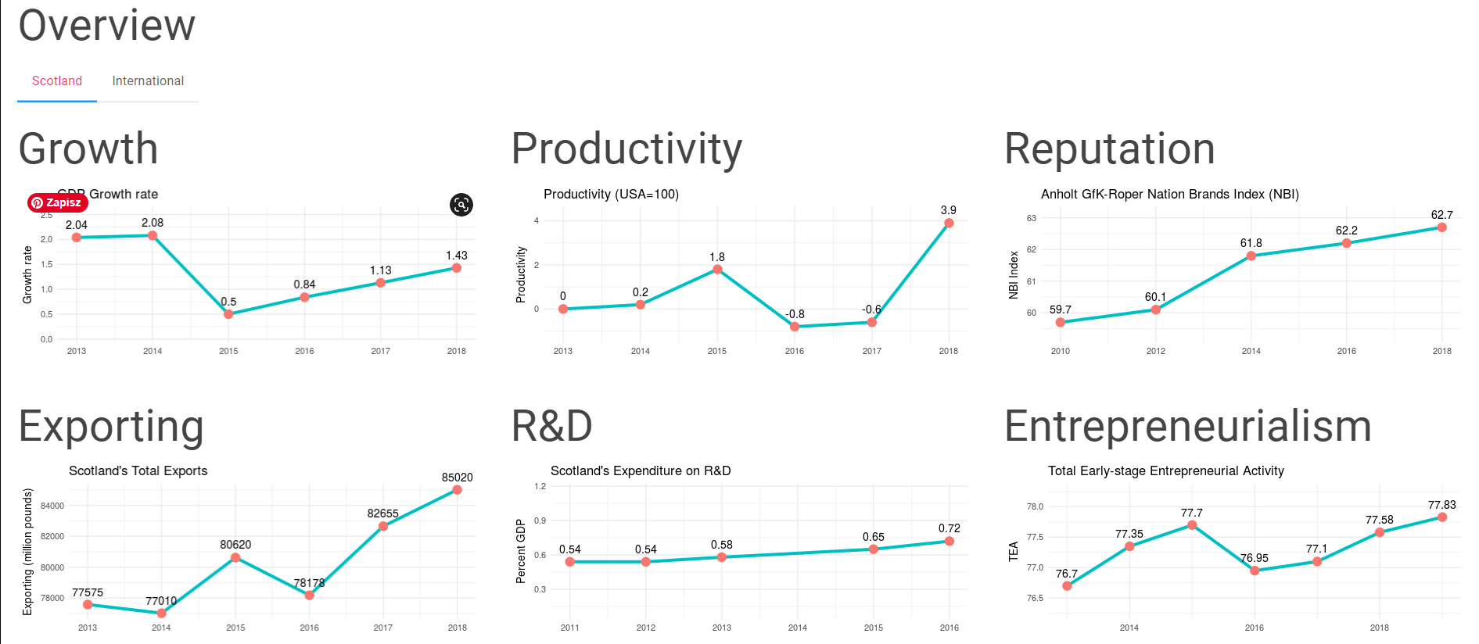

Please modify csv files located in the highlighted folders:

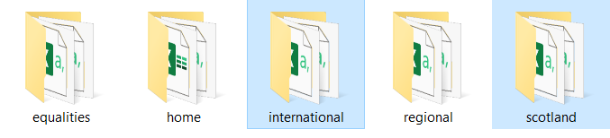

as an example to add year 2019 to Growth chart for Scotland, find appropriate csv file:

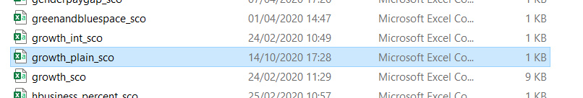

And simply add a new row of data:

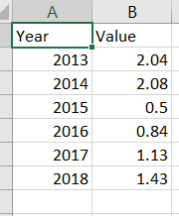 🡪 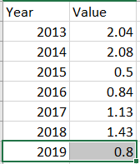

**Part 2. (Helen MacGregor)**